Unit One - The Adversaries

Unit One - Outline of Topics

- Review of Microbes (viruses, bacteria, fungi, protozoa, helminths, arthropods, normal microbiota)
- Host Defenses
- Nonspecific Defenses
- Defenses against entry
- Physical
- Chemical
- Biological
- Defenses of the interior
- Complement cascade
- Acute phase proteins
- Interferons
- Phagocytic cells
- polymorphonuclear leukocytes
- monomorphonuclear leukocytes
- Nonspecific cytolytic cells
- Specific Defenses
1. T lymphocytes
- Recognition of specific antigen (TCR and MHC)
- Activation against a specific antigen (role of APC and T_{H})
- Response to specific antigen
- T helpers
- T cytotoxic
- T regs
2. B lymphocytes
- Recognition of specific antigen (BCR)
- Activation against a specific antigen (role of APC and T_{H})
- Response to a specific antigen
i. Plasma cells
ii. Memory cells (primary vs secondary response)

Unit One - Background Terminology/Concepts – will not be covered in lecture

Obligatory Steps For Infectious Microbes:

Phenomenon | Step | How
1. Entry | attach and enter into body | evade host's natural protective and cleansing mechanisms
2. Spread | local or general spread in body | evade natural barriers and immediate local defenses
3. Multiplication | multiply | but many offspring will die in host
4. Evasion | evade host defenses | evade phagocytic and immune defenses long enough for full cycle in host to be completed
5. Transmission | exit from body | leave body at a site and on a scale that ensures spread to fresh host
6. Pathology | cause damage in host | not strictly necessary but often occurs

Pathogen - agent capable of causing disease
Pathogenicity – ability to cause disease

Frank pathogen= obligate pathogen– causes disease in a healthy host by direct interaction

Opportunistic pathogen- may cause disease under the right conditions

Virulence – degree or intensity of pathogenicity.
Dependent on:
- Invasiveness – ability of organism to spread
- Infectivity – ability of organism to leave point of entry
- Pathogenic potential – degree pathogen causes damage

Virulence factors – individual characteristics of a specific strain of microbe that confer virulence

Colonization (esp. by bacteria/yeast) – establishment of a site of replication – dependent on attachment

Symbiosis - an association of two different species of organisms.

Commensalism - one species uses the body of another species as a habitat and possibly as a source of nutrition.

Mutualism - a reciprocal relationship between two species.

Parasitism - one species in a relationship benefits and the other does not.

------

Respiration - use electron transport chain with an external e- acceptor (like O₂ or NO₃) as the terminal e- acceptor

Fermentation - no external e- acceptor, one of the substrates involved accepts the e-

Facultative fermenter – will respire in the presence of external electron acceptors and ferment in their absence (Ex. Escherichia coli)

Obligate aerobe - must have O₂ because only O₂ can serve as the terminal e- acceptor (Ex. Bacillus spp.)

Facultative anaerobe - will use O₂ for aerobic respiration if it’s present but will switch to fermentation or anaerobic respiration if no O₂ (Ex. E. coli)

Aerotolerant anaerobe - can't use O₂ as an external e- acceptor, but not killed by it.

Strict or obligate anaerobe - killed by exposure to O₂ (Ex. Bacteroides fragilis)

Microaerophilic - grows optimally in presence of oxygen concentrations that are below atmospheric concentrations (ex. the streptococci)

------

Inflammation - the body’s response to injury or infection, which may be acute or chronic.

Acute inflammation - the immediate defensive reactions to any injury. It involves swelling, redness, heat, and pain.

Edema - excessive accumulation of fluid in the tissues.

Erythema - abnormal flushing of the skin caused by dilation of the blood capillaries.

Opsonin - a molecule that attaches to cells, provides a bridge to receptors on phagocytic cells, and enhances the rate of phagocytosis

Cells of the Immune System
(White Blood Cells = WBC = leukocytes)

Monocytes Mononuclear
Macrophages (differentiated monocytes, found in tissues) leukocytes
(agranulocytes)
Phagocytes
Neutrophils
Eosinophils Polymorphonuclear
Basophils leukocytes
Mast cells (differentiated basophils, found in tissues) (granulocytes)

Natural Killer (NK) cells Large Granular Lymphocytes (LGL)
Killer (K) cells

Cytotoxic T cell (T_{C})
Lymphocytes Helper T cell (T_{H}) T cells
Regulatory T cell (T_{regs})

Effector B cells/ Plasma cells
Memory B cells B cells

Origins of Cells of the Immune System

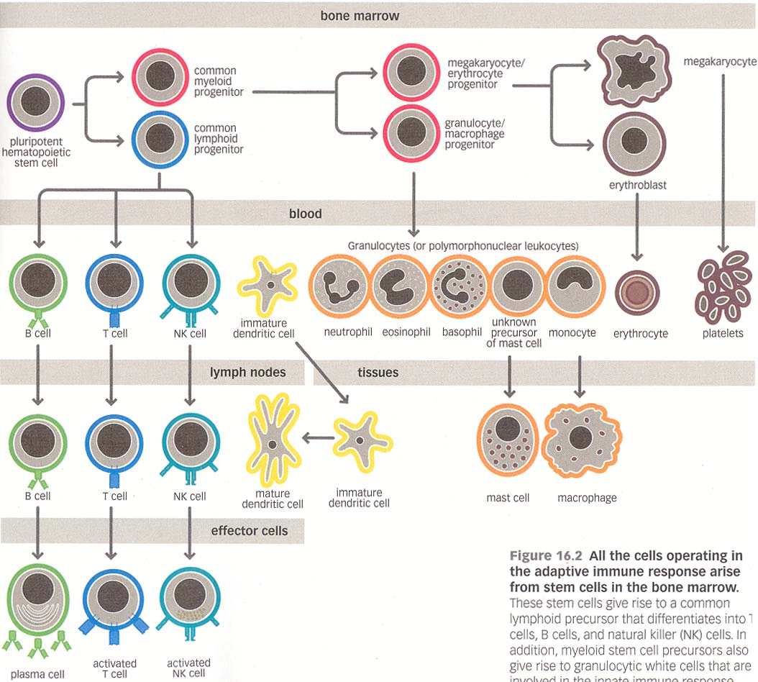

UNIT ONE – THE ADVERSARIES

I. The Microbes

Objectives:

To Review:
- important structural features of viruses
- sequence of steps during viral infection
- consequences of viral infections at a cellular level
- important structural features of bacteria
- key differences between Gram positive and Gram negative cell walls
- clinical significance of LPS, capsules, flagella, fimbriae, and pili
- important features of eukaryotic pathogens: fungi, protozoa, helminths, arthropods
- distribution and significance of normal microbiota by way of clinical cases

A. VIRUSES - Obligate intracellular parasites

Common structural features
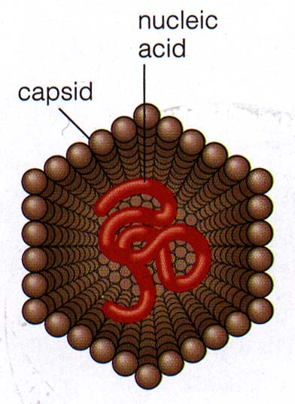
1. Genetic material - DNA or RNA, ss or ds

2. Outer coat - capsid - composed of subunits called capsomers

Nucleic acid + capsid = nucleocapsid

Only nucleocapsid = naked

Nucleocapsid surrounded by a lipid and protein envelope = enveloped
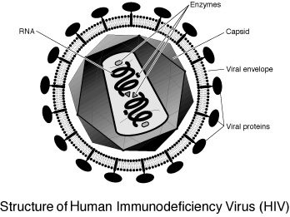

*Outer surfaces (capsids or envelopes) impt cause they 1st make contact w/ host cells.

Viral infection of host proceeds through several steps:

1. Entry into body of host - 4 routes
1) inhalation of droplets -
2) ingestion -
3) direct transfer -
4) bites of arthropod vectors -

2. Adsorption to target cell(s) in host – specific interaction between virus surface molecules and receptors on target cells ***

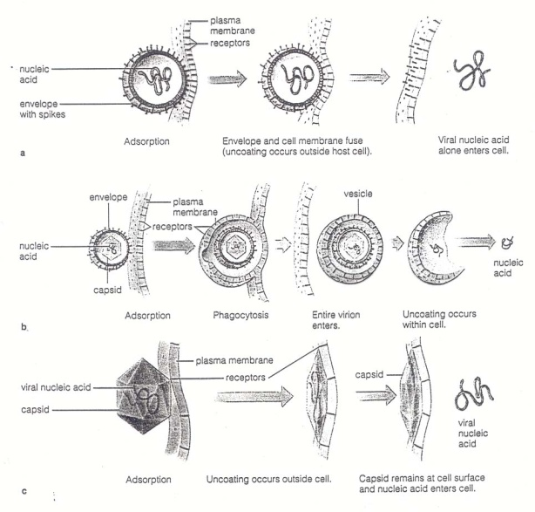
3. Entry into target cell - 3 mechanisms
1) Fusion

2) Receptor-mediated endocytosis (RME)

3) Translocation

Entry step ends with release of viral nucleic acid inside host target cell.

4. Multiplication w/in the target cell (obligate intracellular) – complex process

1) synthesis of viral mRNA
DNA viruses may use host RNA polymerase -- viral DNA viral mRNA

RNA viruses have to use viral RNA polymerases
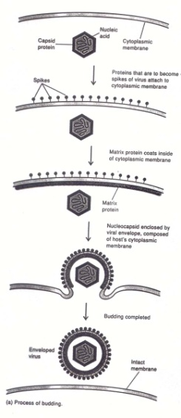
- translation of viral proteins in host cytoplasm using host ribosomes – viral mRNA can displace host mRNA

- replication of viral nucleic acid

- assembly of nucleic acid & capsomers into new nucleocapsids (= viral progeny)

5. Release from host cell (immediate or delayed) – 2 mechanisms
1) lysis -

2) budding (acquisition of envelope) –

Pathology - effects of viral infection on the targeted cell

- lysis –

- persistence –

- latency ( lytic) –

- transformation –
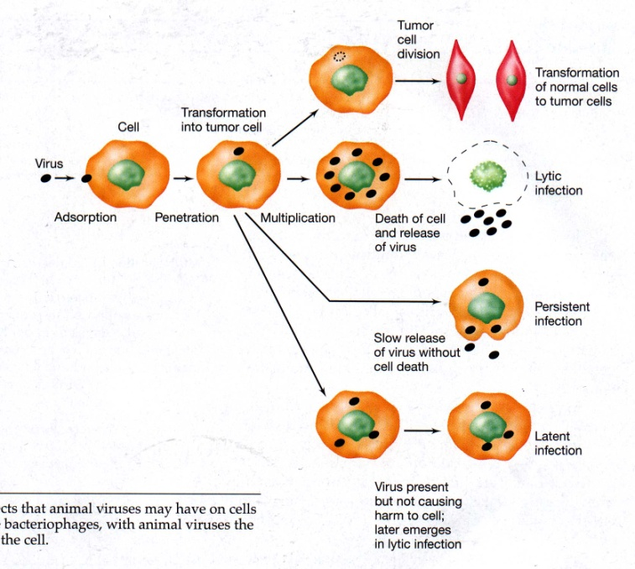

CONCEPT CHECK - Viruses
In the space below, in your own words, describe in complete detail:
1) the significance of surface projection – target cell receptor interactions in viral infections

2) the two mechanisms by which an enveloped virus may enter into a target host cell

B. BACTERIA - prokaryotes

Common structural features

1. Genetic material – ds, circular DNA = “chromosome”

2. Ribosomes are only organelle – 70S (30S + 50S)

3. Cell membrane – site of many metabolic functions

4. Cell wall – shape, rigidity, strength; impt in virulence and immunity

Compound responsible for strength of cell wall is peptidoglycan (hexose sugars + amino acids) – unique to bacteria

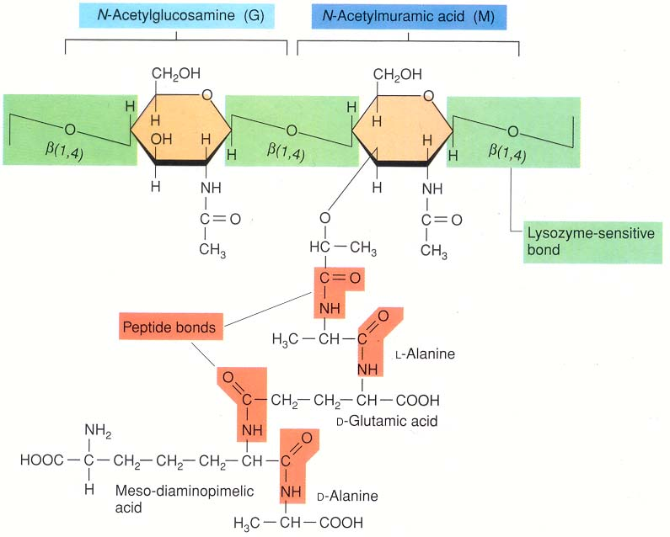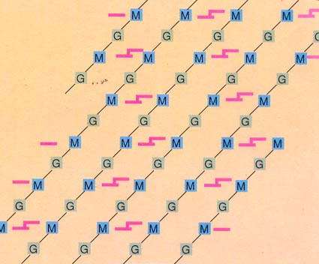

Differences in cell wall structure - Gram positive vs. Gram negative

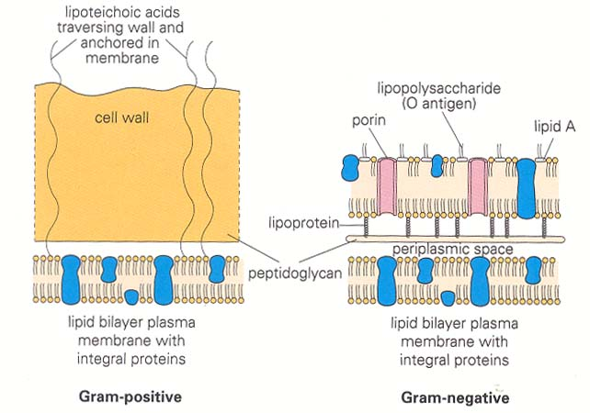

Gram positive
peptidoglycan layer is thick
- highly polar hydrophilic surface
- Lipoteichoic acids = LTA
- resists activity of bile
- digested by lysozyme
- synthesis is disrupted by penicillin and cephalosporin antibiotics (more in Unit 4)

Gram negative
peptidoglycan layer is thin, overlaid by outer membrane that contains lipopolysaccharide and lipoprotein
- outer membrane is polar, but lipids are hydrophilic
- Lipopolysaccharide = LPS
  - carbohydrates antigenicity
  - lipid A is toxic = endotoxin induces fever, increases vascular permeability, etc. (more Units 2 & 3)

5. Structures exterior to the cell wall in some bacteria (more common in pathogens)

a. Capsule – high molecular weight polysaccharides slimy and sticky

clinically relevant for 2 reasons
1) attach to a wide variety of surfaces *
2) more resistant to engulfment by host defense cells **

b. Flagella
1) allow bacteria to move
2) proteins are strongly antigenic/immune stimulating

c. Fimbriae (aka “common pili”, esp. in the Neisseria)
1) attachment (fimbriae adhesins to target cell membranes)
2) evading engulfment

d. Pili (aka “sex pili”)
1) exchange of genetic info, incl. antibiotic resistance (more in Unit 4)

Bacterial infection of host proceeds through several steps:

  - Entry into body of host – 3 routes
1) direct contact
2) ingestion
3) fomites (inanimate objects)

  - Adhere to, colonize, (and possibly invade) host tissues or cells

  - Evasion of host defenses (more in Unit 2)

  - Multiplication in the host (extracellular or intracellular)

  - Pathology (more in Units 2 and 3)
1) toxins
2) host immune response

  - Transmission – usually passive in body fluids

EUKARYOTIC PATHOGENS

C. FUNGI

1. Morphology

- cell wall contains chitin; plasma membrane contains ergosterol
- yeast vs mold

hyphae mycelium

Dimorphic - 2 forms – yeast and mold

2. Reproduction mold vs yeast

spores division
budding

3 types of fungal infections = mycoses
1) superficial –

2) subcutaneous –

3) systemic or deep -

Infections are most serious in immunocompromised.

D. PROTOZOA

1. Infection
extracellular or intracellular

2. Reproduction
asexual in humans, sexual absent or in insect vector.

3. Evasion of host defenses
extracellular – prevent or delay recognition of antigens
intracellular - avoid intracellular killing mechanisms

4. Transmission
bites of insects
ingestion
sexually transmitted

E. HELMINTHS – multicellular worms

1. Exs. tapeworms, flukes, nematodes

2. Have complex life cycles

3. Transmission
fecal-oral
ingestion of larvae in tissues
active penetration by larvae
bites of insects

F. ARTHROPODS

- Exs. mosquitoes, biting flies, fleas, ticks, lice
- increases potential for infection with viruses and protozoa

NORMAL MICROBIOTA = Indigenous microbiota (= Normal flora)

- 10¹² eukaryotic cells in adult human - 10¹³ prokaryotic

Clinical significance
1. common contaminants of clinical specimens
Fig 8.1 and Fig 8.2

2. opportunistic pathogens

In class mini clinical cases

