Urinary Tract Infections and Sexually Transmitted Infections

I. Overview
A. Urinary
- Function - transport products from inside of body to outside
- Free of microbes (sterile) except where the outflow meets the skin

Urinary Tract Infections (UTI)
- Almost always bacterial
- Usually acquired as ascending infections
- Most originate from fecal microbiota - self-inoculation
- Differential lists varies depending on whether infection is acquired in the community or in the hospital, and whether the infection is uncomplicated or complicated (e.g., persons with abnormal UT)
Community- acquired | Hospital-acquired
1. E. coli (80-90%) | 1. E. coli (40%)
2. S. saprophyticus (5-15%) | 2. Klebsiella, Enterobacter, Serratia, Pseudomonas aeruginosa (25%)
3. Proteus mirabilis | 3.GPC
4. Klebsiella, Enterobacter, Serratia, Pseudomonas aeruginosa | 4. Proteus mirabilis
viruses - rare

Predisposing Factors
Anything that:
- Disrupts urine flow
- Prevents complete emptying of bladder
- Promotes microbial access
Females | Females & males | Males
Pregnancy | Renal stones | Enlarged prostate
Intercourse | Tumors
 | Neurological disorders
 | Catheters

Virulence Factors of Urinary Pathogens (examples):
E. coli – uropathogenic strains (O and K serotypes) = UPEC
- pathogenicity island
- P fimbriae (attachment)
- capsular acid polysaccharide (resist phagocytosis)
- membrane active cytotoxins

S. saprophyticus
- adherence to uroepithelium (high proportion of bladder cells w/ adherent bacteria)
- microbistatic to GP and GN
- urease

P. mirabilis
- flagella (motility)
- urease

Clinical Syndromes
Lower UTI
  - urethritis (urethra)
Symptoms - dysuria

2. cystitis (bladder)
Symptoms - rapid onset of dysuria; increased urgency/frequency
Urine - cloudy - pyuria (inflammation) or bacteriuria (bacteria); blood (hematuria)

3. prostatitis (prostate)
Symptoms - dysuria, increased frequency, low back pain, systemic indications (fever)

Upper UIT
1. pyelonephritis (renal parenchyma)
Symptoms - cystitis + more severe systemic indications (fever)
Complications - septicemia, loss of renal function

Collecting Urine Samples
- Voiding (Midstream clean-catch)
- Urinary catheter
- Suprapubic bladder aspiration

Laboratory Diagnosis of Urinary Tract Infections
- Read in text pages 257-259 carefully, especially pay attention to how to tell what is significant bacteriuria
B. Genital/Reproductive
- Only system that is significantly different in males & females
- Largely free of microbes, except for the vagina

Sexually Transmitted Infection (STI) ( = Sexually Transmitted Disease (STD) = venereal disease (VD)
- Incidence is increasing
- Almost no vaccines
- Rampant on college campuses
- Often asymptomatic

Sexually Transmitted Diseases - Top Ten in US By Occurrence

Pathogen | Disease
- Human Papillomavirus (HPV) | genital warts; associated w/ cervical cancer
- *Chlamydia trachomatis D-K.  C. trachomatis L1, L2, L3 | non-specific or non-gonococcal urethritis  lymphogranuloma venereum
- Candida albicans | vaginal thrush, balanitis
- Trichomonas vaginalis | vaginitis, urethritis
- Herpes simplex virus (HSV) | genital herpes
- *Neisseria gonorrhoea | gonnorhea
- HIV | AIDS
- *Treponema pallidum | syphilis
- *Hepatitis B virus | hepatitis
10. Haemophilus ducreyi | chancroid

#1 Human Papilloma Virus (HPV)
- Transmission – sexually
- Entry – attach to target cell via capsid protein, enter via RME
- Incubation – 1-6 months
- Pathology – dyplasia = abnormal growth
- Symptoms – warts on penis, vulva, perianal regions (types 6 or 11) – BUT majority asymptomatic
- Complications – high-risk HPV types 16, 18, 31, 33, and 35 are strongly associated with cervical neoplasia
- Treatment (Txt) – asymptomatic and subclinical not treated; warts treated
- Prevention - vaccine
#2. Non-gonococcal urethritis - Chlamydia trachomatis - Obligate intracellular bacterium – Most common reported STI – 1,100,230 reported cases in U.S in 2009, 44,873 cases in Michigan.
- Transmission – sexual
- Entry – abrasions
- Attachment - to receptors on host cell, parasite-induced endocytosis
- Incubation – 2-6 weeks or longer
- Pathology – cells destruction & inflammation
- Symptoms – asymptomatic infection is common, esp. in women OR urethritis
- Complications –systemic dissemination, infertility – in women also PID, ectopic pregnancy – in infants pneumonia, trachoma.
- Treatment (Txt) – tetracycline, doxycycline, azithromycin

#3. Yeast infection or Candida vulvovaginitis - Candida albicans – yeast, part of normal microbiota
- Transmission – normal microbiota of female vagina - disruptions to bacterial vagina community can result in an overgrowth with yeast.
- Symptoms – UTI, intensely itchy/burning, cottage cheesy discharge
- Balanitis (inflammation of glans penis) in 10% of male partners
- Txt – antifungals like micronazole or nystatin (topical) or oral fluconazole

#4. Vaginitis - Trichomonas vaginalis - protozoa
- Transmission – sexual
- Entry – vagina in women; urethra and prostate in men
- Symptoms – vaginitis – copious, yellow/green frothy discharge, rise in vaginal pH
- Txt - metranidazole

#5. Genital herpes - Herpes simplex viruses types 1 and 2 (HSV1, HSV2)
- Transmission – sexual
- Entry - by membrane fusion
- Incubation – 3-7 days
- Pathology -
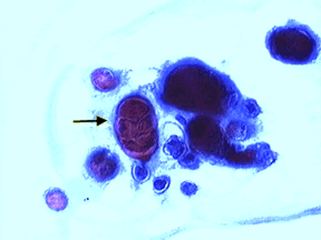 | The herpes virus causes the membranes of host cells to fuse together to form “giant” cells. This picture was taken of PAP smear material and the arrow indicates a giant cell.

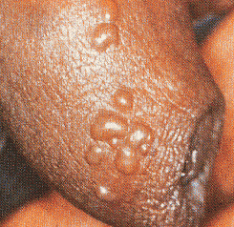 | - Symptoms - First sign – primary genital lesion vesicles ulcer w/tender, swollen nodes, fever, headache, malaise
The herpes virus travels up sensory nerve endings to the root ganglion neurons where it remains in a latent stage for the life of the host.  The herpes virus can not be eliminated by the immune system or by anti-viral drugs.  Herpes infections can re-activate. Virus travels back down the nerve fibers and causes new lesions at the surface of the skin or mucosal membranes. Re-activations are common and are triggered by trauma, stress, and sun. |  |  | 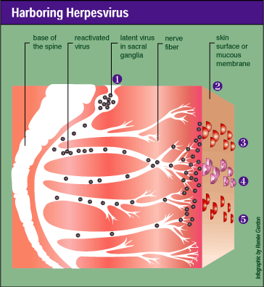
I it is believed that herpes infected individuals may always be somewhat infectious.

- Complications (in addition to reactivation) – aspetic meningitis or encephalitis in adults. Neonatal disseminated herpes or encephalitis.

- Txt – acyclovir (Zovirax), famciclovir, valacyclovir (Valtrex)
#6. Gonorrhea - Neisseria gonorrhoea – 260,530 U.S. in 2009/ 14,471 cases MI
- Transmission – direct, usually sexual, person-person
If the woman has gonorrhea there is a 20% chance during each sexual encounter that she will transmit to her male partner. If the man has gonorrhea, there is a 50-90% chance he will transmit to his partner (female or male).
- Asymptomatically infected individuals, almost always women, form a major reservoir of infection.
- Entry – vaginal or mucosa of penis – or other mucous membranes (pharynx, conjunctiva)
- Attachment - via common pilus (which undergoes antigenic variation), Opa proteins. Invade non-ciliated epithelial cells
- Incubation – 2-7 days
- Pathology – see picture– what process causes the damage?

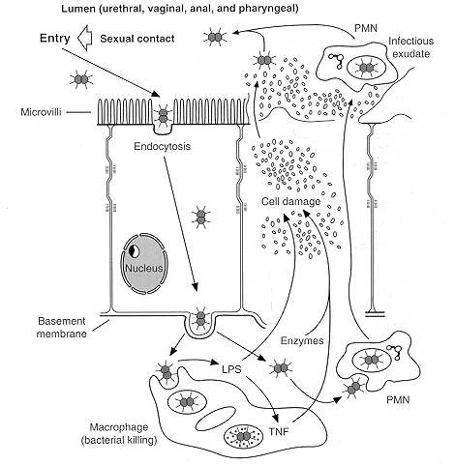

- Symptoms - First sign in men – dysuria, purulent discharge (shown center and a Gram stain of shown right, see the GNC engulfed by the PMNs).  - First sign in woman – vaginal discharge if symptomatic, BUT 50% asymptomatic | 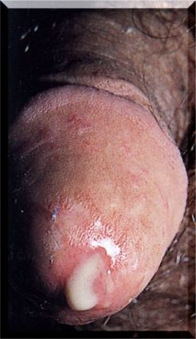 | 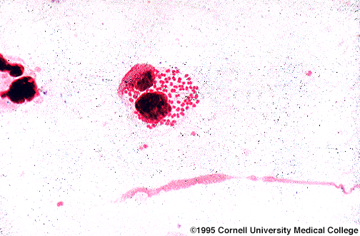

- Complications – similar to Chlamydia – pelvic inflammatory disease (PID) and/or damage to the fallopian tubes resulting in infertility in 10-20%, disseminated infection (1-3%), opthalmia neonatorum (neonate blindness shown at right – this is what newborns get silver nitrate drops to prevent, mandated in MI). | 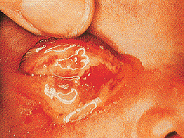

- Txt – Cefixime, Ciprofloxacin PLUS treat for Chlamydia – very often people who have gonorrhea have Chlamydia and visa versa.

#7. Acquired Immune Deficiency Syndrome (AIDS) - Human Immunodeficiency Virus (HIV) – globally, 2.7 million new infections in 2008
- Transmission - Sexually transmitted (but not a disease of the reproductive tracts but of the immune cells, specifically CD4+ cells like macrophages and T_{H}), also transmitted by blood.
- Incubation – 2 weeks to 3 months, sometimes 6 months.
- Read in text pages 275-283.
#8. Syphilis ((#3 bacterial STI in U.S.) - Treponema pallidum – 12,833 U.S. in 2009/ 231 cases MI

- Transmission – close physical contact; usually sexual, saliva, blood - 1/3 of those exposed to the syphilis spirochete will become infected.
- Entry – small abrasions
- Incubation – 10-90 days, 3 weeks is average
 | - Symptoms - First sign – chancre – develops after 2-4 weeks - apparently not painful! | 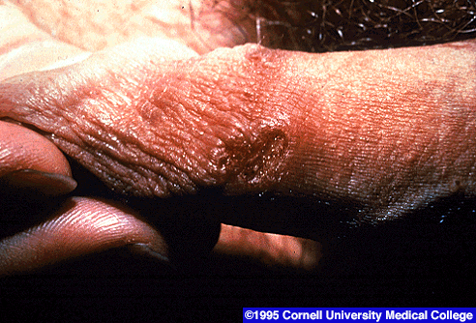
- Primary – the bacteria multiply in regional lymph nodes and cause swelling.
- Secondary – after 3-6 weeks, the bacteria multiply and produce lesions in many sites. Symptoms include myalgia, headache, fever, and rash (in 75-100% of cases).
- 2/3 are cured at this point but 1/3 develop go into a latent phase that can last 3-30 years, which can then progress to tertiary.
- Tertiary – bacteria again multiply and spread. Host cell-mediated response causes progressive destruction of neuro-, cardio-, skin, and/or joints.
- Complications – congenital syphilis (intrauterine death, congenital abnormalities)
- Txt – arsenic (historical), penicillin (modern) or doxycycline for pen-sensitive patients.

If you haven’t seen the movie “Miss Evers’ Boys” you could watch this for extra credit (I know some rental places carry it, in the “true stories” section). It is about the Tuskegee experiments on syphilis conducted by the U.S. government. Relate presentation of syphilis in the movie with info from Medical Microbiology.

