I. Introduction

During these exercises we will examine aspects of neural/neuromuscular function. The nervous system is one of the body’s two communication systems. Specifically, it is the system that underlies, among other functions, rapid communication, memory, and consciousness. This system consists of both central components, specifically the brain and spinal cord, and peripheral components including nerves that carry signals back and forth between the CNS and the periphery (glands, muscles, sensory organs, etc.). Rapid communication within the nervous system underlies simple reflexes - such as jerking your hand away from a source of heat before you sustain sever injury – to complex processes such as thought. Such capacities are possible because neurons, the functional units of the nervous system are specialized cells that generate electrical signals and extend processes – axons or dendrites, depending on whether the process transmits information away from or toward the cell body, respectively – from short to long distances away from the cell body. As such neurons provide a means for rapid information transmission over sometimes long distances and can form simple to highly complex circuits underlying a variety of essential functions such as breathing feeding, thinking; remembering, etc.
The electrical signals generated and transmitted by neurons are termed action potentials. The capacity to generate action potentials is not unique to neurons. For instance, muscle cells also rely on action potential production to mediate contraction. Although information along the length of a neuron is transmitted as an electrical signal, the transfer of information from one neuron to another - or from a neuron to another type of cell, such as a skeletal muscle fiber - often requires the release and diffusion of chemical messengers through a space where two cells are closely apposed; that is such transfer requires chemical synaptic transmission. The purpose of these exercises is to examine the membrane/ionic/synaptic basis of information transfer within the nervous system and at the neuromuscular junction (a specialized synapse).

II. Physiology Background

A. Action potentials – Within a Single Neuron
- Question: How do neurons generate the brief change (almost a reversal) of their trans-membrane voltage that is the action potential?
Answer:
  - All cells maintain a voltage (potential energy generated by the attractive force between oppositely charged particles) between the inner and outer surfaces of their outer membrane.
  - The trans-membrane voltage is caused by the uneven distribution of certain ions, across the cell membrane. Relative to its external environment, the interior of neuron contains a high concentration of positively charged potassium ions, a low concentration of positively charged sodium ions and an abundance of negatively charged organic molecules (Fig. 1). Thus, when possible, sodium ions will rapidly diffuse into a neuron, thereby adding positive charge to its inner surface and increasing its voltage. In contrast, potassium ions tend to diffuse out, removing positive charge and decreasing neuronal voltage.
  - The negatively-charged organic ions are trapped within the neuron. The others can only move into or out of the neuron through protein pores (ion channels) in the cell membrane.
  - At rest the neuronal membrane is much more permeable to potassium than to any other ion. Thus the trans-membrane distribution of potassium disproportionately affects the resting voltage. As a result, typical values for the resting membrane potential of mammalian neurons range between -90 and -50 mV, within a few mV of the potential that would be set by the passive movements of potassium alone.

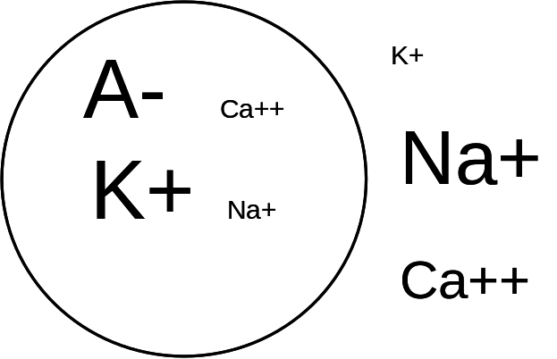
Fig. 1: Distribution of the primary ions contributing to the neuronal resting membrane potential. The relative size of the ion symbols represents their relative concentration. E.g. Na+ concentrations within the interstitial fluid vastly exceed those within the neuron.

  - Threshold: An action potential is generated when a neuron’s resting voltage increases enough to trigger a regenerative opening of sodium-selective ion channels. Any factor that makes the resting voltage more negative will inhibit the production of neural activity. For instance, increasing a neuron’s permeability to potassium will increase the diffusion of this positively-charged ion out of the neuron, thereby decreasing the neuron’s voltage and inhibiting production of activity.
  - Following activation by a depolarizing stimulus, V-gated Na+ channels rapidly inactivate (saying “close” really isn’t enough; a special inactivation gate closes during inactivation, separate from the gate closed at resting potential).
  - At about the same time that V-gated Na+ channels are inactivating, V-gated K+ channels finally open in response to the depolarization. Thus, at about the same time that Na+ influx drops off, a (relatively) large efflux of K+ begins.
  - By removing + charge, this efflux brings the membrane voltage back to and even below the RMP (repolarization and hyperpolarization)
  - RMP is established via MAINLY PASSIVE means. That is, at all hyperpolarized membrane V, above the K+ eq pot., K+ and NA+ will move into the cell through non-gated channels and bring the membrane back to RMP. The direct contribution of the NA-K-ATPase is minimal.

- Question: How do action potentials travel?
Answer: The depolarization caused by the opening of Na channels in a membrane segment will passively spread to adjacent segments of membrane thus depolarizing them and if possible, bringing them to threshold. Thus, the action potential is regenerated at each segment of membrane that it brings to threshold and is thereby propagated along the surface of the axon.

- Question: Why do action potentials only travel away from their point of initiation?
Answer: Refractory periods – note inactivation of Na channels in 1.f. above; also see text, note that this phenomenon applies to all excitable tissues, not just axons. Essentially, recently depolarized portions of membrane (e.g., where the AP has already been) remain unresponsive to stimuli for a brief period. During the absolute refractory period, a neuron will simply not generate an AP in response to any stimulus. The V-gated Na channels are still inactivated and residual K+ conductance is high, thus stimuli can’t affect an inflow of Na+, and even if they could, the residual K+ conductance would interfere with depolarization. During the relative refractory period, Na+ channels are resetting, some can open, residual K+ conductance is decreasing and stimuli affect the membrane voltage, only these stimuli need to be more intense than normal to overcome residual K+ conductance and residual Na+ channel inactivation.

B. Action Potentials – Within a nerve (hundreds of axons)

As noted above, within each neuron, the AP is occurring in only one segment at any given time.

However, a nerve is a bundle of axons. In some of these exercises you will be recording from a nerve using extracellular electrodes. Thus, your data should appear to be a bit different from the textbook coverage which deals with intracellular changes along a single axon. Specifically, you will observe the following properties of a nerve AP:

- The voltage of the compound AP will differ from the textbook values obtained with intracellular recording techniques. This is because you are observing small fluctuations in the voltage of the interstitial fluid caused by multiple cellular APs and you are doing so from a relatively great distance.

- The second phase of the compound AP is NOT an after hyperpolarizaiton. It is simply the compound AP at the second recording electrode. With extracellular recording techniques you only record the fact that voltage changes are occurring, you can't record an after hyperpolariztion. Thus, when the compound AP arrives at the first recording electrode the trace (recording) will deflect upwards (or downward if the electrodes are reversed or a setting is reversed... either way, no big deal) as in Fig 2.B. Note: the signal before the Action potential is called the stimulus artifact. If the action potential propagates to the second recording electrode the trace will deflect downwards as in Fig 2.C. After the compound AP passes the second recording electrode the trace will return to baseline as in Fig 2.D.

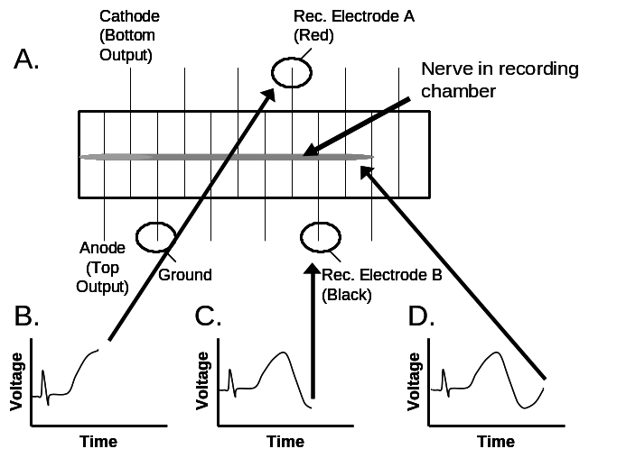
Fig. 2. Recording compound action potentials from the frog sciatic nerve. A. Cartoon of the nerve within the plexiglass recording chamber. B,C. Recordings from PowerLab Scope as the compound AP reaches the first and second recording electrodes, respectively. D. Recording after the compound AP has passed the second recording electrode and the segment of nerve above that electrode has returned to baseline voltage.

- Amplitude changes - Since you are recording APs from many axons, you will be able to see the effects of few to many all-or-none APs summating. Thus, larger amplitude APs reflect the summed activity from many axons, whereas smaller compound APs represent the activity of relatively few axons. This occurs because:
  - different axons have different thresholds and
  - the stimulus is not acting on all axons to the same degree.

- Strength-duration relationship: Not only will stronger (higher voltage) stimuli cause more axons to reach threshold, longer stimuli will have a similar effect. What is the basis for this type of relationship? An applied voltage doesn't instantaneously depolarize the cell membrane. Rather, adding (+) charges to the membrane's inner surface (charging) takes time. The amount of time required to add enough charges to reach threshold is closely related to the strength (intensity AKA strength AKA voltage) of the stimulus. That is, a very strong (high voltage) stimulus will charge the membrane quickly and generate an AP, even if it is of short duration. On the other hand, a week stimulus, applied for a longer period, may eventually generate the same response (assuming that it is strong enough to ever depolarize the membrane to threshold) as the stronger stimulus (see fig 3).

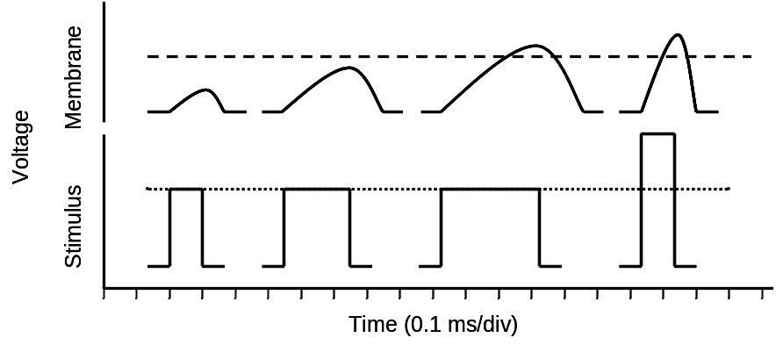
Figure 3. Effects of various stimuli on membrane voltage. Note that longer duration stimuli will add more charge to the membrane and thereby depolarize it further than will shorter duration stimuli of the same strength. Also note that larger strength stimuli will depolarize the membrane more quickly than lower intensity stimuli.

- Unlike the intracellular experiments outlined in your textbook, you will most likely need to use a large stimulus in the range of 50 mV to 5 V Instead of 4 mV to reach threshold. Most of the stimulus travels through the interstitial fluid and bathing fluid to ground. That is, most of it never depolarizes the neuronal cell membrane. Hence a 400mV stimulus may only depolarize a neuron a few mV.

C. Neuron/Nerve Conduction Velocity

The conduction of an action potential along a nerve is a very rapid event. In 1/100th of a second an action potential can move from 1 cm to 1 m. Hence, conduction of this excitation from one part of the body to another occurs in a matter of milliseconds (1000 msec = l second).

From a comparative standpoint, the velocity at which a single neuron conducts an action potential is dependent on two primary factors:
- degree of insulation (myelinization) – myelin is a form of cellular electrical insulation formed by wrapping processes of glial cells around sections of axon.
- axonal diameter – as diameter increases axial resistance to electrical spread decreases and the velocity of signal transmission increases.

Thus, large diameter, well myelinated axons rapidly transmit action potentials from one node of Ranvier to the next where the signals are regenerated (propagated) and rapidly transmitted to the next node. Axons lacking myelination need to regenerate the action potential at each segment of membrane. Otherwise the AP would rapidly decrement (decay) with distance, and would thereby fail to transmit information along the entire length of the axon.

D. Skeletal Muscle, Muscle Fiber.

In a portion of this exercise, we will utilize a sciatic nerve/gastrocnemeus muscle preparation to examine chemical synaptic transmission (below). We are all aware that skeletal muscles are tissue, which moves, or at least maintains the position of skeletal elements by applying tension to these elements. Individual skeletal muscles are like nerves in many ways. First, like the nerve, a skeletal muscle is made up of many longitudinally arranged tubular cells termed muscle fibers. Actually, each of these fibers was formed developmentally from the fusion of many myocytes, primordial muscle cells. Second, as with neurons, muscle fibers are excitable, that is they are capable of producing action potentials. In the case of skeletal muscle fibers, action potentials mediate contraction by evoking the release of Ca++ from intracellular stores, such as the sarcoplamic reticulum, a specialized from of endoplasmic reticulum.

E. Chemical Synaptic transmission

When we study chemical synaptic transmission we are examining the conversion of information from an electrical signal to a chemical signal, and then back to an electrical signal that evokes an observable response. That is, we’ll first evoke an AP in the sciatic nerve. Action potentials arriving at the terminals of the activated axons will evoke the release neurotransmitter onto the gastrocnemeous muscle fibers. In this case the chemical messenger is an excitatory neurotransmitter known as acetylcholine or ACh. When the ACh binds to receptors on the muscle fiber membrane it opens ion channels that allow Na+ to enter the fiber’s cytosol, thereby depolarizing it and causing a muscle fiber action potential. This action potential in turn causes the release of Ca++ from intracellular stores and thereby causes the fiber to contract. By varying the strength of our nerve stimulus, we can alter the number of axons/muscle fibers activated and thereby alter the overall strength of the muscle twitch (contraction).

III. Laboratory Exercises

III.A. Exercise Set 1: Neurophysiology of the Frog Sciatic Nerve

Common Procedure - Preparing the Frog Sciatic Nerve – Note the nerve prep and the Neuromuscular prep should be performed on separate specimens, perhaps during separate lab periods. Your frogs will already have been double-pithed by your TA.

1. Remove the skin from one leg and the lower "back" of your double-pithed frog. Don’t worry about being gentle. Using scissors cut the skin all the way around the “hip” joint. Using strong forceps or hemostats, grab some free skin on the leg, wrap it tightly around the forceps a few times and yank it down to the frog’s foot. Lay the frog on a paper towel dorsal side up.

2. Locate the caudal end of the urostyle (see fig 4) and make an incision through the body wall on the lateral side into the abdomen, proceeding towards the head. Cut through the pelvic girdle bone, extending the cut to where the frog’s “shoulders” would be, if frog’s had shoulders. Next, make a transverse incision all the way across the dorsal body wall – yes, this means cut through the cranial portion of the spinal column - and then lay back the cut tissue. You should be able to locate nerves running from the spinal cord into the leg.

3. With a glass probe and forceps, separate the dorsal muscles of the thigh to reveal the yellowish-white sciatic nerve. Using a squirt-bottle filled with saline solution to keep the nerve moist.

4. You should be familiar with the following precautions prior to handling the nerve.

a. Never stretch the nerve.
b. Do not allow the nerve to touch the skin surface or cut muscle.
c. Do not let the nerve dry out.

5. Tie a ligature around the nerve roots on the side of choice, and cut the nerve between the ligature and the spinal cord.

6. Gently hold the nerve by the thread (without stretching) and carefully tease the surrounding tissues away from the nerve all the way to the knee. Cut only the smaller branches as the nerve travels to the knee.

7 Without stretching the nerve, hold it up out of the way with the thread, tie off the nerve as close to the knee as possible, then cut the nerve from the gastrocnemius muscle as far distally (from the spinal column) as possible. Keep the nerve moist using frog saline.

8. If they aren't already on, turn on the PowerLab and computer. In Windows, choose "Neuro_Settings". This way the computer can control the PowerLab, stimulate your nerve and acquire your recordings.

9. Connect the recording leads and stimulating leads into a recording chamber. A ground lead should be placed between the stimulating and recording electrodes (See fig 5) below.

10. Carefully place the nerve on the electrodes in the recording chamber making sure that the nerve covers the two stimulating electrodes and at least 3 recording electrodes. Place a couple of ml of frog saline in the bottom of the nerve chamber to keep the air moist and place a cover glass slide on the chamber. Do not fill the chamber with saline (thereby shorting out the electrodes) or place distilled water or Lysol on the nerve.
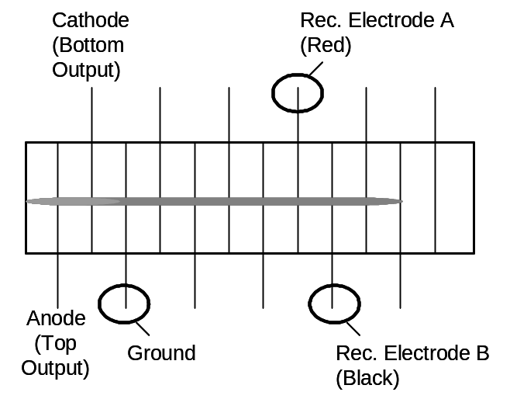
Figure 5. Placement of the sciatic nerve in the recording chamber. Note that the nerve crosses the anode, the cathode and numerous potential recording electrodes.

Experiment 1 - Determination of subthreshold, threshold, submaximal, and maximal stimuli

Purpose: Determine the response of the nerve to various stimuli so that you can employ a relatively constant stimulus protocol during the remaining experiments.

Theory: During this experiment you will employ stimuli of constant duration and variable amplitude as you evoke varying responses from the nerve preparation. Stimulus duration is held constant herein because, as noted above, the duration of a stimulus affects the extent to which the stimulus charges the cell membranes (Fig 3). By holding the duration of the stimulus constant you can isolate the effect of changing stimulus strength on action potential production.

Procedure:
- In the “stimulator control panel” under the settings menu, set the stimulus duration to 0.1 msec and the voltage (labeled Amplitude or Ampl – don’t confuse this with AP amplitude, it only refers to the strength or voltage of the stimulus) to 0.05 volts. Close the stimulator window and give the nerve a single shock by pushing “Start” in the lower right hand corner of the “Scope” window. Gradually increase the voltage with the arrows in the “stimulator control panel” and apply subsequent stimuli by pushing “start” after each increment. At some point this procedure will generate an action potential on the “Scope” screen.

***** THE VOICE OF EXPERIENCE: “DON’T CONFUSE THE AMPLITUDE OF THE COMPOUND AP, WHICH YOU WILL MEASURE FROM THE RECORDING, WITH THE “AMPLITUDE” OF THE STIMULUS, WHICH YOU SET IN THE STIMULATOR DIALOGUE. THESE ARE SEPARATE VALUES; ONE IS A STIMULATOR CONTROL SETTING, THE OTHER IS A MEASURE OF THE NERVE’S RESPONSE TO A STIMULUS. *******

- The voltage at which you first observe an AP is the “Threshold Voltage”. Record this value. Note that it represents the minimum stimulus that will evoke an action potential in the nerve. Note that the time interval between the stimulus artifact and the recorded action potential depends on the distance between the cathode stimulating electrode and the first recording electrode.

- Increase the voltage and note how the response (amplitude of the action potential in mV, but not the stimulus) of the compound action potential changes in response to the submaximal stimuli. Continue to increase the voltage until the compound amplitude of action potential has reached its highest peak. This represents the maximal stimulus. You may need to increase the stimulus voltage range in the stimulator control under the settings menu.
- If at a duration of 0.1 ms you don’t reach a maximal stimulus, increase the duration of your stimulus to 0.2 ms and repeat steps 1-3.

Data and Questions:
- Record the effects of subthreshold, threshold, submaximal, and maximal stimuli on the nerve. For each stimulus record both its voltage (strength) and duration. Note whether each stimulus evoked an action potential. If so, record the peak to peak amplitude of the action potential.
- Outline why the amplitude of the compound AP increases as the stimulus voltage increases above threshold; that is, why does the amplitude of the compound AP increase with increasing stimulus intensity?
- Does the variable amplitude of the compound AP violate the “all-or-none” principle outlined in your text book’s treatment of neuronal action potentials? Why or why not?

Experiment 2 - Strength-Duration Relationship

Purpose: Examine the relationship between the strength of the stimulus and its duration, in terms of the degree to which the stimulus brings axons to threshold (a handy measure of how well a stimulus is depolarizing the membrane). To do so, you will try to keep the amplitude of the compound action potential more-or-less constant as you alter the duration of the stimulus. This can be achieved by adjusting the stimulus voltage (strength/intensity) until the amplitude of the action potential has the same amplitude as with the original stimulus settings.

Theory: Electrical stimuli depolarize cells by adding positive charges to the inner surface of the cell membrane (i.e., by charging the cell membrane). As noted above, this charging process takes time (Fig. 3). Remember that strong (intense) stimuli add charge very quickly, while weaker stimuli do so more slowly.

Procedure:
- At the onset of the experiment, use a submaximal stimulus (at duration = 0.05 ms) to generate an action potential approximately 75% of maximal amplitude (record the amplitude for comparison). Then evoke action potentials with the stimulus duration set to 0.1, 0.15, 0.2, 0.25, 0.3, 0.35, and 0.4 ms.

- At each duration, adjust the stimulus voltage until the amplitude of the action potential is more-or-less equal to the starting amplitude.

Data and Questions:
- Record these stimulus voltages along with their corresponding durations.

- Using this data, plot a strength duration curve in Excel. That is, plot stimulus voltage as a function of stimulus duration. Feel free to refer back to the Excel tutorial as needed.

- Why does a lower strength stimulus produce the same action potential response (as a higher strength stimulus) when the stimulus duration is increased?

- Based on the strength-duration curve what is the minimum voltage that will produce a response? What is the minimum duration that will evoke a response?

Experiment 3 - Response of the nerve to two subthreshold stimuli (temporal summation)

Purpose: In this experiment you will attempt to bring your nerve cell membranes to threshold by summating two sub-threshold stimuli.

Theory: Not only does the cell membrane take time to charge, it also takes time to discharge (repolarize). That is, the voltage change caused by an electrical stimulus (or during any other graded potential) will decay over a period of time. If another stimulus is applied to a membrane before the first has decayed completely, then the two stimuli can add together. This is similar to what happens when graded potentials summate over space and/or time. See figs 6-14, 6-15 and 6-29 in your text.

Procedure:
- Set the stimulus duration to 0.05 msec.
- Lower the stimulus voltage until an action potential is first absent.
- In the stimulator control panel, switch to “mode: double”; set the interval to 2 msec; set the duration and strength (amplitude/intensity) of the second stimulus equal to that of the first. Click “OK”.
- Apply a pair of pulses by pressing “Start”. You should only see a pair of stimulus artifacts.
- Now, decrease the length of the interval in 0.1 msec intervals. At some short interval, you should see that the pair of stimuli generates a small compound AP. Continue to decrease the interval and see if you get a larger compound AP. Congratulations, you’ve affected temporal summation!!!

Data and Questions:
- In your data sheet, record whether or not an action potential was observed at each stimulus interval, and the amplitude of the AP, if one occurred.
- Draw a qualitative plot of the two stimuli (voltage against time) as they were received by the cell membranes at a) intervals too long to affect summation, b) intervals just short enough to allow enough summation for a few axons to reach threshold, and c) at intervals so short that many axons were activated.

Experiment IV - Conduction Velocity

Purpose: As noted earlier, action potentials propagate quickly along an axon. In this experiment, you will determine how quickly the bundle of axons in your nerve prep propagates/conducts (on average).

Theory: As noted above, action potentials travel quickly along an axon with the velocity within any given neuron being dependent on a) the diameter of the axon, b) the frequency at which the action potential needs to be regenerated in order to prevent its premature decay. Conduction velocity (CV) can be experimentally determined by measuring the time that the action potential takes to cover a discrete length of nerve and then simply plugging these values into the formula for velocity: Velocity = distance / time.

Procedure:
- Place your recording electrodes as far away from the stimulating electrodes as possible.
- Given that each electrode wire in your recording chamber is 0.5 cm from the next, measure the distance between the cathode (see chamber figure above) and the first recording electrode.
- Evoke a maximal AP.
- Use the cursors in the "Scope" window to measure the time that it took for the action potential to travel from the site of stimulation (end of stimulus artifact) to the first recording electrode (Fig. 6).
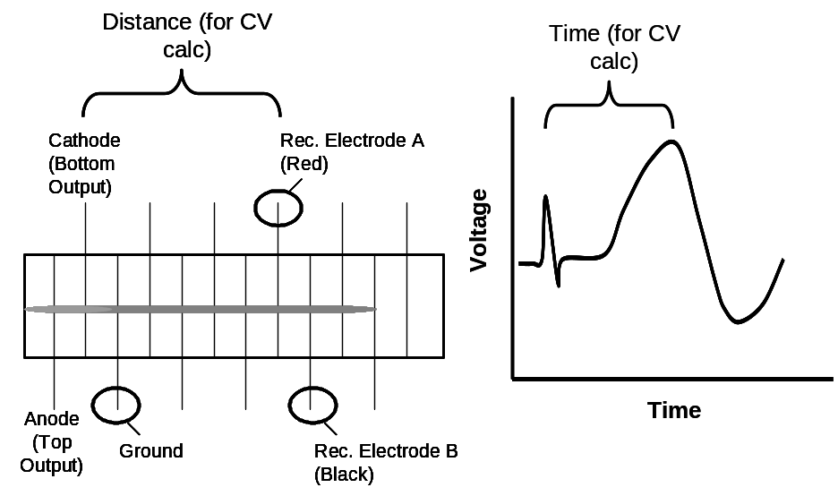
Fig. 6. Measurements used to calculate conduction velocity.

Data and Questions:
- Calculate conduction velocity (= distance from #2 / time from #4). Convert this value into M/sec. and record it on the data sheet (show your calculations). How does this compare to the textbook values

Experiment V - Refractory Periods

Purpose: As noted way up in the sections on physiology background, refractory period is the time after an action potential occurs in a segment of membrane during which that segment of membrane is non-responsive, or less responsive to subsequent stimuli. Here you will determine the relative, total and absolute refractory periods for your nerve.

Theory: As you work through this experiment, keep in mind that each neuron within the nerve will exhibit a different absolute, relative and total refractory period. Thus, while some neurons are still in their absolute refractory period, others will be in the relative and yet others will have returned to normal excitability. Thus, we will have a hard time finding a stimulus interval that during which a second stimulus evokes absolutely no response from our nerve. Accordingly we will define refractory periods for a nerve’s compound AP as follows: Absolute Refractory period is represented by the stimulus interval at which the second stimulus evokes a smaller compound AP that the first AND increasing the strength of the second stimulus does not bring the amplitude of the second AP back to that of the first. The relative refractory period comprises the time following the absolute refractory period during which the amplitude of the second compound AP can be brought back to that of the first by increasing the strength of the second stimulus (See Figs. Within instructions below).

Procedure:
- Using a single stimulus, re-determine what voltage stimulus, of 0.1 msec duration, will generate an AP of just less than maximal amplitude.

- In the stimulator control panel under the settings menu, switch mode to double, set the interval to 10.0 msec. Then set both stimuli to 0.1msec and to the voltage determined in step #1.

- Close the stimulator panel and evoke a pair of APs by clicking on the "Start" button in the Scope window.

- Note that there are two identical APs 10 msec apart (as in the fig. below). Move the cross-hairs to the peak of the second AP and read its amplitude from the top right screen. Ignore the last two decimal places.

- Record the amplitude of this action potential.

- Now, decrease the interval between the stimuli in 1 ms increments until the amplitude of the second compound AP drops, then decrease the interval in 0.1 ms increments. Record the amplitude of the second compound AP at each interval. The longest Interval at which this amplitude drops by at least 0.3 mV (averaged over a couple of stimulations) represents the end of the Total and Relative Refractory Period. Record this value.

This nerve is NOT in the refractory phase:

This nerve is in the refractory phase. But is it relative or absolute?

- To determine whether the 2nd stimulus is applied during the relative or absolute refractory period, increase its strength (voltage). If doing so brings the amplitude of the 2nd AP back to that of the 1st, then your 2nd stimulus is being applied during the relative refractory period (see 1st fig below). If, on the other hand, the 2nd stimulus, no matter how strong, fails to bring the 2nd AP back to the amplitude of the 1st, then the 2nd stimulus is being applied during the Absolute Refractory Period (see 2nd figure below).

In the figure below, a stronger 2nd stimulus brought the amplitude of the second AP back to that of the 1st. Thus, the 2nd stimulus was applied during the Relative Refractory period
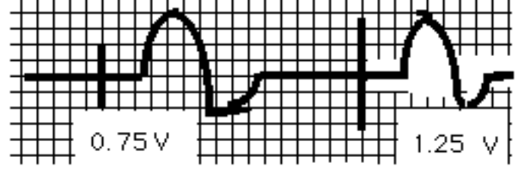

The interval where the amplitude of the second AP can not be returned to its original value is termed the absolute refractory period. In the recording below, the much stronger 2nd stimulus is being applied during the Absolute Refractory Period:
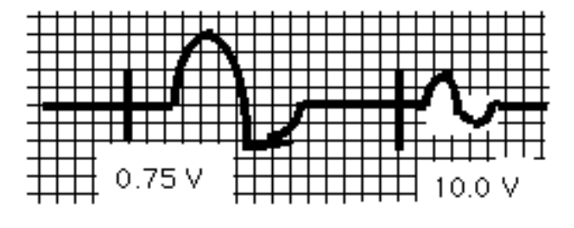

If you were to plot the Absolute, Relative and Total refractory Periods on a time line, they would be oriented like this:

1st AP initiated, time = 0 time = ca 1.5 msec time = ca 4.5 msec

Absolute Relative

Total

Data and Questions:
- Record the data listed in the preceding procedure.
- Draw a timeline, similar to the preceding for the refractory periods of your nerve.
- At the level of the single neuron, what is the basis of the relative refractory period?
- At the level of the single neuron, what is the basis of the absolute refractory period?
- Synthesize an explanation of why you were able to produce a reduced-amplitude compound AP during the absolute refractory period, when during this period a single neuron should not be able to generate an action potential.
III.B. Experiment Set 2: Chemical Transmission

General Purpose: To examine the chemical basis of cellular communication.

General Theory:
As noted above, the transmittal of information from one cell to another often occurs via chemical transmission and this chemical transmission is initiated by an electrical event, the action potential. Referring to neuron to neuron chemical transmission in his Mammalian Physiology Lab Manual (1st ed.), CMU’s own Dr. John I Scheide eloquently notes:

“The action potential sweeps down the axon until it reaches the axon terminal (presynaptic membrane). The depolarization phase of the action potential causes calcium channels to open. Intracellular calcium increases due the increase of calcium movement into the cytoplasm by calcium channels located in the cell membrane and organelles. This increase in cytoplasmic calcium causes synaptic vesicles that contain a neurotransmitter substance to migrate to and fuse with the presynaptic membrane. The vesicle contents are released into the synaptic cleft (exocytosis). The degraded by enzymes, or bind to specific receptors on the postsynaptic membrane. These specific receptors are linked to ion channels or a second messenger system resulting in either a hyperpolarization or depolarization of the postsynaptic membrane. If the membrane depolarizes to threshold, an action potential occurs and the signal is perpetuated in the new nerve cell.”

In this set of experiments we will examine chemical synaptic communication using a nerve-muscle preparation, rather than a purely neural preparation. Thus, we will examine neuromuscular transmission, rather than inter-neuronal synaptic communication. Nonetheless, the compound set of neuromuscular junctions in the nerve-muscle prep affords the advantage of an easily observable postsynaptic response to nerve stimulation (muscle contraction) thereby eliminating the need for post-synaptic electrical recording, which is oftentimes a tricky proposition. Please review the neuromuscular background provided in the initial “Physiology Background” section of this lab set and the relevant portions of your text/notes.

Common Procedure – Dissection:
- As is always necessary when experimenting with living tissue, keep the tissue moist with saline throughout dissection and experimentation.
- Remove the skin from one leg of your double-pithed frog. Don’t worry about being gentle. Using scissors cut the skin all the way around the “hip” joint. Using strong forceps or hemostats, grab some free skin on the leg, wrap it tightly around the forceps a few times and yank it down to the frog’s foot. Lay the frog on a paper towel dorsal side up.
- Use glass probes and (sparingly) scissors to separate large thigh muscles to remove the yellowish/whitish ropelike nerve running from the hip into the lower leg.
- Use the glass probes to gently tease the nerve free from surrounding connective tissues. Don’t cut the nerve or otherwise damage it.
- Be careful to prevent either the nerve or the muscle from ever touching the frog’s skin.
- Repeat this procedure with the nerve going to the other leg.
- Throughout all procedures, keep the tissues wet with saline.

Experiment 1: Stimulation

Purposes
- Determine the optimal nerve stimuli required to evoke a muscle contraction
- Compare the sensitivity the neuromuscular preparation to direct stimulation with its sensitivity to nerve stimulation

Theory: See preceding discussions of nerve compound AP, the various classifications of nerve stimuli (i.e. subthreshold, etc) and neuromuscular transmission. Moreover, keep in mind that stimuli that evoke more axonal APs will activates more motor units (i.e., activate more muscle fibers) and thereby cause a stronger contraction.

Procedure:
- Set the PowerLab stimulator to generate stimuli 1 msec in duration, and 0.1 volt amplitude.
- Place the stimulator probe electrodes under the nerve such that the nerve rests on both probe ends; make sure that the stimulator probes don’t touch any other frog tissue.
- Starting at the lowest voltage setting, apply several (e.g., 5) pulses at each voltage.
- If there is no response, gradually increase the stimulus voltage until a muscle twitch (contraction) or kick is observed.
- Repeat this procedure with the other nerve, starting at the lowest voltage.
- Determine the threshold voltage of direct muscle stimulation by placing the stimulating electrodes on the muscle tissue and gradually increasing the stimulator strength.

Data and Questions
- Record the amplitude of the threshold stimulus
- Why does the strength of the muscle contraction seem to vary with stimulus intensity?

Experiment 2: Effects of Leg Ligation on Neuromuscular Transmission

Purpose: Simulate neuromuscular dysfunction and in so doing examine the steps involved in neuromuscular communication.

Theory: As noted in the “Physiology Background” and in the “Theory” portion of this set of experiments, neuromuscular communication requires a) propagation of a neural action potential, b) the release of chemical messenger, c) diffusion of chemical messenger, d) binding of the neurotransmitter to postsynaptic receptors and the directly or indirectly resultant opening of ion-channels, e) generation of a postsynaptic potential, in muscle fibers this would be called an endplate potential and f) generation of a muscle action potential. If any one of these steps is impaired, then normal neural/neuromuscular communication cannot occur.

Procedure:
- Pass a piece of green string under one of the nerves that you have freed from the thigh musculature.
- Wrap the string around the leg, not the nerve
- Tighten the string so that no blood can reach the lower leg
- Immediately verify that the ligation procedure did not affect tissue threshold, if your threshold changed record the new threshold.
- Test the threshold of the ligated preparation every 30 seconds for 10 min.

Data and Questions:
- Did your threshold change over the course of the experiment?
- Why might the threshold have changed (review the energy requirements of neurons in your textbook)?
- What is one pathological condition that this experiment might mimic?

Experiment 3: Effects of Curare Injection

Purpose: To examine the role of cholinergic signaling in neuromuscular transmission.

Theory: The imminent physiologist Claud Bernard noted that South American Indians captured prey animals by paralyzing them with a dart that had been treated with an extraction from a particular tree bark. The location on the animal where the dart hit was not important. The bark extract contained a poison, curare that would enter the prey animal’s blood stream when the dart hit. As the curare circulated though the animal it would antagonize Acetylcholine receptors at the neuromuscular junction thereby preventing muscle excitation and contraction. As a result, the animals were immobilized, but not immediately killed by the dart. This exercise will investigate the effect of curare on the myoneural junction

Procedure:
- After completing the ligation experiments, alert your laboratory assistant that your frog is ready for curare injection.
- The lab assistant will inject curare into your frog.
- Immediately following curare injection determine nerve threshold.
- Every 5 minutes thereafter re-test nerve threshold and note changes.
- If the nerve threshold goes above 10 volts, or below 2 mV, discard the muscle and conclude the experiment
- If an obvious alteration in neuromuscular function is not evident within 30 minutes after curare administration, the dose will be increased.

